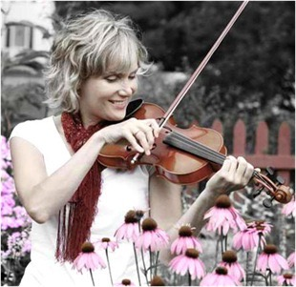
Kelli brings her crisp fiddling, Angelic voice and fiery step dance to all of her performances
Saturday, August 11, 2018
7:30 p.m.
St. Paul’s Presbyterian Church,
517 Main Street, Winchester
$20.00
Advance ticket sales: CUP OF JOE’S
OR CALL 613-774-3565

GOLD SPONSORS  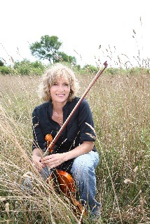 | SILVER SPONSORS  Food and Refreshments provided by St. Paul’s Ladies Aid  Proceeds to be shared with  House of Lazarus  Dairyfest and St. Paul’s | BRONZE SPONSORS  