Presbyterians Read Lenten Study: Entering the Passion of Jesus
A Beginner's Guide to Holy Week

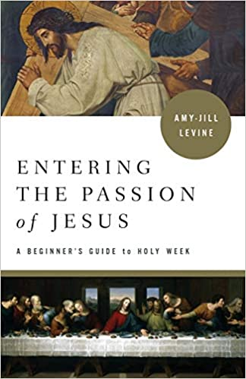

In Lent 2021, Presbyterians across the country are again invited to join a denomination-wide book study. Author, professor, and Jewishscholar, Amy-Jill Levine (author of the Advent study book - Light of the World: A Beginner’s Guide to Advent), dives deep into the biblical texts surrounding the Passion story in Entering the Passion of Jesus. Levine looks into characters such as Judas, Pilate, Caiaphas, the disciples, and the women around Jesus to understand their relationships and roles in the Passion story. Entering the Passion of Jesus provides a rich and challenging learning experience for small groups and individual readers alike.
First Presbyterian Church, Brockville, invites you to be a part of this study during Lent. The study will be offered by Zoom to welcome participants safely. Reverend Marianne Emig Carr will facilitate the study and discussion. This will be a six-week study, starting at 11 am on Wednesday, February 17th and running until Wednesday, March 24th. There are also options to do your own personal study, or to join the Presbyterians Read Facebook Group (Presbyterians Read | Facebook) if you are not able to join us on Zoom! You can order the book through Parasource Canada (www.parasource.com)or through Amazon, Indigo or your favourite local bookseller.
Please contact Reverend Marianne (rev.marianne@myhighspeed.ca) so that she can send you the study guide materials and the Zoom link for the sessions.

